Adolescent Program Newsletter
April 2017
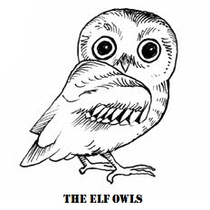

MSAE Upcoming Events
Conference Month
Apr 3-7
Spring Break
Apr. 14
Talk with the Guide – Ms. Stacey
Montessori vs. Traditional Middle
School
Apr. 22
School Carnival
Apr. 28
Adolescent Variety Show

“Success consists of going from failure to failure without the loss of enthusiasm.”
- Winston Churchill

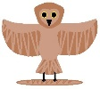
As we are moving into the end of the school year we have a great many things happening…
We are in the midst of preparing for our year-end variety show, embarking on individual science experiments, planning and preparing for our Academic Fair in May, continuing the bakery and starting to think about our 8th years’ graduation.

For our Variety show this year we are incorporating skits from areas that we studied. We will have a 10-Minute Shakespeare skit, some American playwrite skits, some Broadway aspects and an original skit written by us.
On May 11th, we will have an Academic Fair to show off some of the work we have done this year and we hope that everyone will come by and see what we have to share with you. Along with other work that we have picked, we will have our individual Science Experiments on display, as well as some of our Art projects from throughout the year.

Class Trip
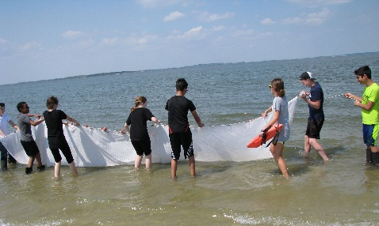
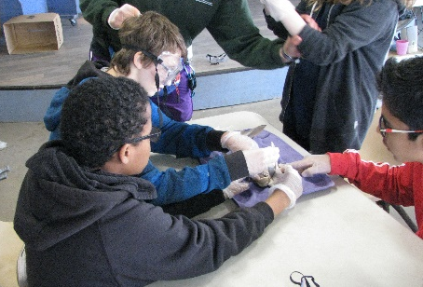
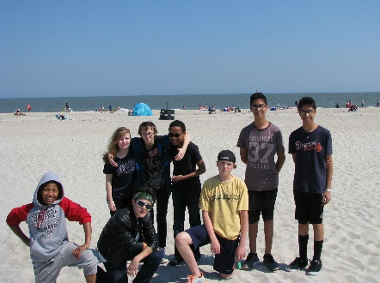

We had a wonderful time on our trip to Tybee Island at the end of March. We spent time learning about Beach Ecology, what lives in the surf, the maritime forest and dissecting sharks. We also got to visit Fort Pulaski and take a dolphin tour.

